Xray progress 02/01/2026
1. Xray Setup
Xray Cloud Overview
Xray is a native Jira app for test management. In Xray Cloud, configuration is split between global (organization-level) settings and project-level settings. Xray works on top of Jira issue types, workflows, permissions, and screens.
Key characteristics:
- Uses Jira issues for all test artifacts
- Fully integrated with Jira permissions and workflows
- Supports manual, automated, and exploratory testing
Project-Level Configuration
Configured per Jira project:
- Issue type availability (Test, Test Execution, Test Plan, Test Set, Precondition)
- Workflow associations for Xray issue types
- Screens & fields (steps, preconditions, environments, revisions)
- Test environments (if not inherited globally)
- Automation settings (CI integration usage per project)
Project admins control how Xray behaves inside their project without impacting others.
Global vs Project Settings
Global Settings (Xray Admin):
- Default test environments
- Global custom fields & field behavior
- Automation & CI integrations (e.g., Jenkins, GitHub Actions)
- REST API access and limits
- Global issue type configuration
Project Settings (Project Admin):
- Enable/disable Xray issue types
- Associate workflows & screens
- Override environments
- Project-specific permissions via Jira

Rule of thumb:
Global = platform-wide behavior
Project = execution and structure choices

2. Xray Issue Types
Test – Core Test Case Structure
Represents a single test case.
Contains:
- Test type (Manual / Cucumber / Generic / Unstructured)
- Steps & expected results (manual)
- Scenario definitions (BDD)
- Preconditions
- Requirement links (Stories, Bugs, Tasks)
Tests are reusable assets and should not be execution-specific.
Test Execution – Execution Structure
Represents one execution cycle of tests.
Key properties:
- Execution date & environment
- Tester
- Status per test (Pass / Fail / To Do / Executing)
- Defects logged per test run
A Test Execution answers:
“What was tested, when, where, and with what result?”
Test Plan vs Test Set
Test Plan
- High-level container for planning
- Usually aligned to a release, sprint, or milestone
- Can include:
  - Tests
  - Test Sets
  - Test Executions
Used for:
- Coverage tracking
- Release-level reporting
Test Set
- Logical grouping of Tests
- No execution or reporting context by itself
- Often used for:
  - Regression packs
  - Smoke tests
  - Feature-based grouping
Key Difference:
- Test Plan = planning & reporting
- Test Set = organization & reuse
Precondition Reuse
Preconditions are standalone issue types:
- Can be linked to multiple Tests
- Changes propagate to all linked Tests
- Reduces duplication and inconsistency
Best practice:
- Use Preconditions for setup logic shared across many tests
- Avoid embedding setup steps repeatedly inside tests

3. UI & Panels
Xray Panels (Issue View)
Displayed on Jira issues (Story, Bug, Test):
- Tests panel – linked tests & status
- Test Coverage panel – requirement coverage
- Test Executions panel – execution history
These panels provide contextual visibility without leaving the issue.

Coverage View
Shows:
- Requirement → Test coverage
- Execution status distribution
- Gaps (untested or failing requirements)
Commonly used by:
- QA Leads
- Product Owners
- Release Managers
Execution View
Focused on execution progress:
- Test run status
- Defects created during execution
- Environment and assignee
Supports both:
- Manual execution
- Automated result imports
Defect Visibility
Defects can be:
- Linked at test run level (preferred)
- Linked directly to Tests (less common)
Benefits:
- Traceability: defect ↔ test ↔ requirement
- Accurate failure analysis per execution
Navigation Shortcuts
- Traceability Report → end-to-end visibility
- Test Repository → folder-based test browsing
- Execution Board → quick execution access
- Jira issue links → fast drill-down

4. Roles & Permissions
QA Access
Typically allowed to:
- Create & edit Tests, Test Sets, Test Executions
- Execute tests
- Link defects
- View coverage & reports
Controlled via Jira project permissions + issue security.
Developer Role
Usually allowed to:
- View Tests & Executions
- See linked defects
- Trigger or review automated test results
Often restricted from:
- Editing test steps
- Changing execution status manually
Admin Controls
Xray Admin:
- Global configuration
- Automation & API setup
- License and feature control
Jira Project Admin:
- Issue type availability
- Workflow & screen configuration
- Permission schemes
Common Permission Pitfalls
- Missing “Edit Issue” prevents execution updates
- Workflow status restrictions blocking execution
- Screen misconfiguration hiding Xray fields

5. Test Creation & Design
Creating a Test Issue
Tests are created as Jira issues of type Test.
Key fields to complete:
- Summary – clear, behavior-focused name
- Description – high-level intent and scope of the test
- Test Type – Manual, Cucumber, Generic, or Unstructured
- Preconditions – linked reusable setup conditions
Best practice:
- Keep descriptions concise
- Avoid embedding execution-specific data (environments, builds)
Test Description vs Preconditions
Test Description should explain:
- What is being validated
- Business intent or rule being checked
Preconditions should include:
- Shared setup steps
- System state assumptions
- Data or configuration requirements
Use Preconditions when setup is:
- Reused across multiple tests
- Likely to change centrally

Step-Based Tests (Structured)
Used for manual, repeatable scenarios.
Each step includes:
- Action
- Expected result
Best for:
- Critical flows
- Regression testing
- Compliance-heavy projects
Unstructured Tests
Free-form tests without predefined steps.
Best for:
- Exploratory testing
- Early feature validation
- Proof-of-concept testing
Execution typically documented via:
- Comments
- Attachments
- Observations added during execution
Example Real-Project Test Selection
When designing tests:
- Align test scope to Stories / Tasks
- Validate acceptance criteria
- Cover happy paths + key edge cases
Avoid:
- Overly generic tests with no requirement linkage
- Tests that mix multiple unrelated behaviors

6. Test Organization
Test Sets
Logical collections of Tests.
Common usage:
- Reusable groupings
- No execution context
Examples:
- Login-related tests
- API contract tests
Smoke Tests
Small, fast-running subset validating:
- Core system stability
- Deployment success
Characteristics:
- High priority
- Low volume
- Often automated
Regression Grouping
Used to ensure existing functionality remains intact.
Best practices:
- Group by application area
- Keep regression sets stable
- Execute frequently (per sprint / release)
Feature-Wise Grouping
Organize tests by:
- Feature
- Component
- Module
Benefits:
- Easier maintenance
- Clear ownership
- Faster impact analysis

7. Linking Strategy & Traceability
Linking Tests to Stories & Tasks
Primary linkage for requirement coverage.
Benefits:
- Visibility of tested vs untested work
- Clear QA ownership
- Accurate coverage reporting
Recommended:
- Link each Test to at least one Story or Task
Linking Tests to Bugs
Two approaches:
- Execution-level defect linking (preferred)
- Direct Test ↔ Bug linking (less common)
Execution-level linking provides:
- Precise failure context
- Environment-specific traceability
Traceability Visualization
Xray provides:
- Coverage reports
- Traceability matrices
- Requirement → Test → Execution → Defect views
Used by:
- QA Leads for coverage gaps
- Product Owners for release readiness
- Teams for root cause analysis

Sample image of the manual testing of input format

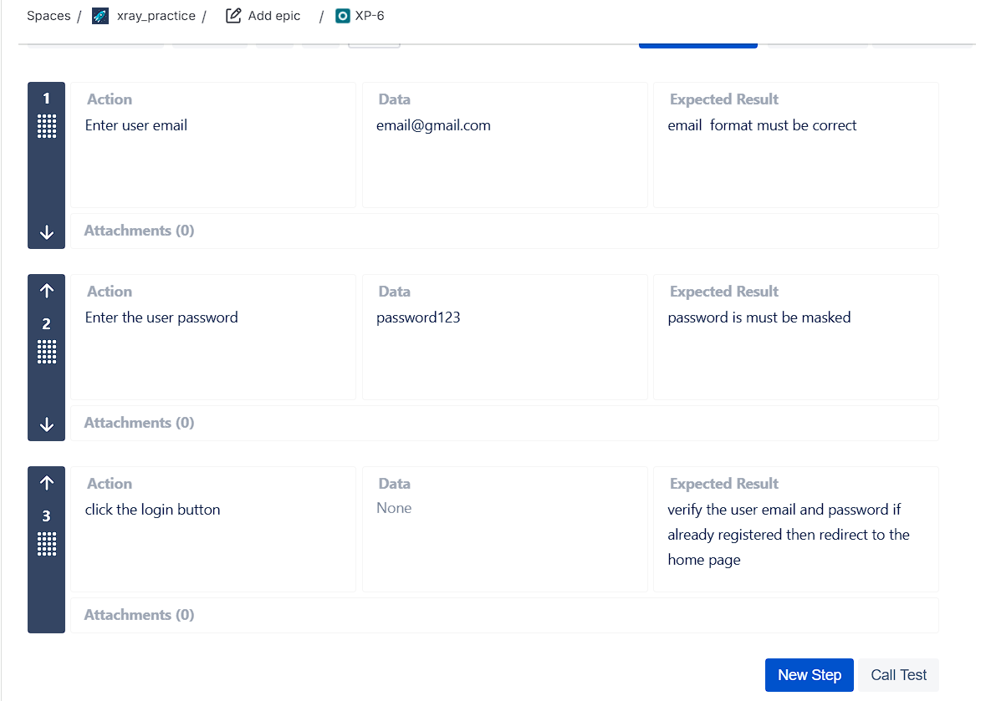

Sample image of test execution

